Question 36
#include<stdio.h>
int main()
{
/* A
AB
ABC
ABCD
ABCDE */

int i,j;

for (i=1;i<=5;i++)
{
for(j=1;j<=i;j++)
{
printf("%c",64+j);

}
printf("\n");
}
}
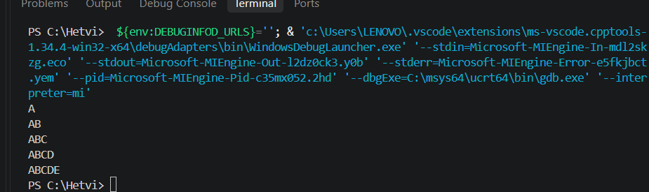
Question 37
#include<stdio.h>
int main()
{
/* 1
12
123
1234
12345 */

int i,j;
for(i=1;i<=5;i++)
{
for(j=1;j<=i;j++)
{
printf("%d",j);
}
printf("\n");
}
}
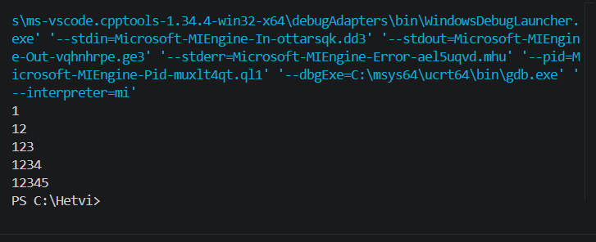
Question 38
#include<stdio.h>
int main()
{
int i,j;
for(i=1;i<=5;i++)
{
for(j=1;j<=i;j++)
{
printf("*");
}
printf("\n");
}
}

{

for(i=1;i<=5;i++)
{
for(j=1;j<=i-1;j++)
{
printf("-",j);
}
printf("\n");
}
}
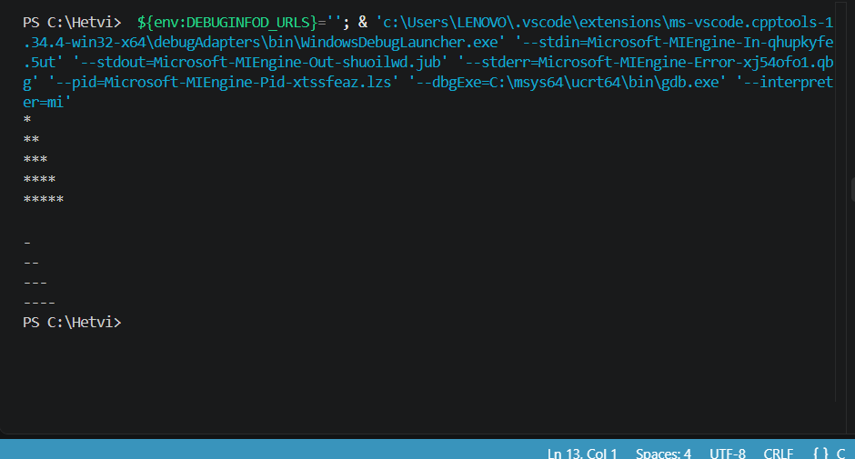
Question 39
/* A
BB
CCC
DDDD
EEEEE */
#include<stdio.h>
int main(){
int i,j;

for(i=1;i<=5;i++){
for(j=1;j<=i;j++){
printf("%c",64+i);
}
printf("\n");
}
return 0;
}
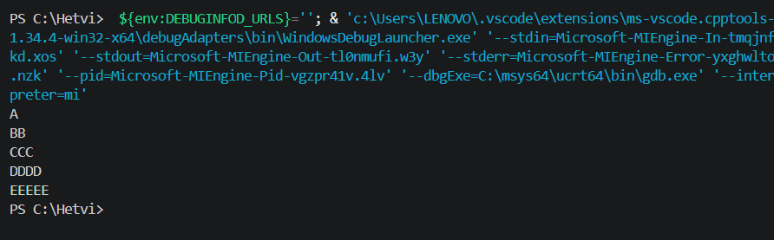
Question 40
/* 10000
01000
00100
00010
00001 */

#include<stdio.h>
int main(){
int i,j;
for(i=1;i<=5;i++)
{
for(j=1;j<=5;j++)
{ if(j==i)
printf("1");
else
printf("0");
}

printf("\n");
}

}
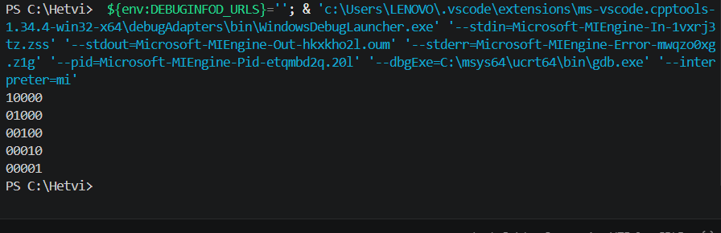
Question 41
/* 1
121
12321
1234321 */
#include<stdio.h>
int main()
{
int i,j;
for(i=1;i<=4;i++)
{
for(j=1;j<=4-i;j++)
{
printf(" ");
}
for(j=1;j<=i;j++)
{
printf("%d",j);
}
for(j=i-1;j>0;j--)
{
printf("%d",j);
}
printf("\n");
}
}
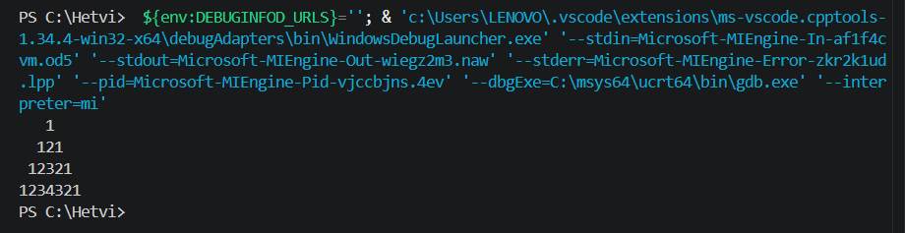
Question 42
/* *
***
*****
*******
*****
***
* */
#include<stdio.h>
int main()
{
int i1,j;
for(i1=1;i1<=4;i1++)
{
for(j=1;j<=4-i1;j++){
printf(" ");
}
for(j=0;j<=2*i1-2;j++)
{
printf("*");
}
printf("\n");
}

for(i1=5;i1<=7;i1++)
{

for(j=1;j<=i1-4;j++)
{
printf(" ");
}
for(j=1;j<=15-2*i1;j++)
{
printf("*");
}

printf("\n");
}

}
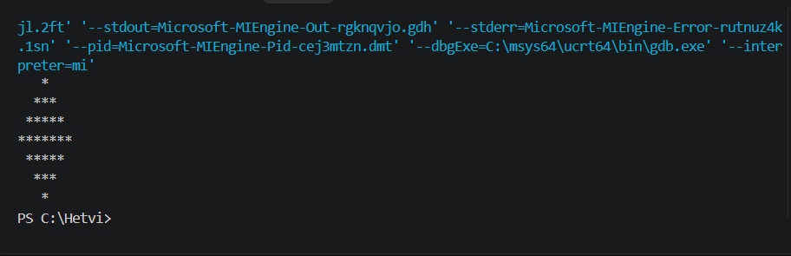
Question 43
// PROGRAM TO RED AND ARRAY OF 10 INTEGER AND PRINT SUM OF NUMBERS
#include<stdio.h>
int main(){
int a[10],i,sum=0;

printf("Enter 10 integers");
for(i=0;i<10;i++){
scanf("%d",&a[i]);
}
printf("Sum of 10 integers:");
for(i=0;i<10;i++){
sum+=a[i];
}
printf("%d",sum);
}
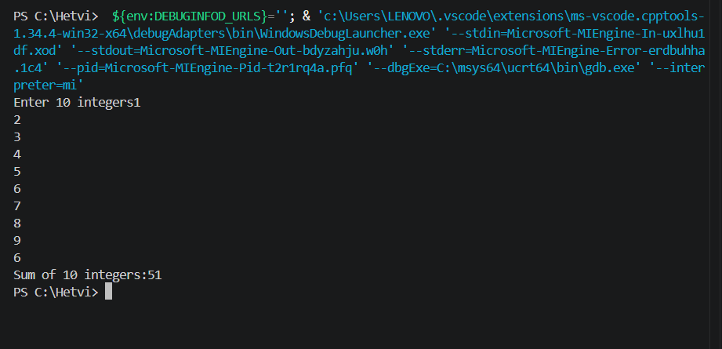
Question 44
//PROGRAM TO READ AN ARRAY OF 10 INTEGER AND COUNT TOTAL NO OF ODD AND TOTAL NO. OF EVEN ELEMENT
#include<stdio.h>
int main()
{
int a[10],i,c1=0,c2=0;
printf("Enter 10 integers");
for(i=0;i<10;i++){
scanf("%d",&a[i]);
}
for(i=0;i<10;i++){
if(a[i]%2==0){
c1++;
}
}
c2=10-c1;
if(a[i]%2==0){
printf("No. of even integers:%d\n",c1);
}

printf("No. of odd integers:%d",c2);

}
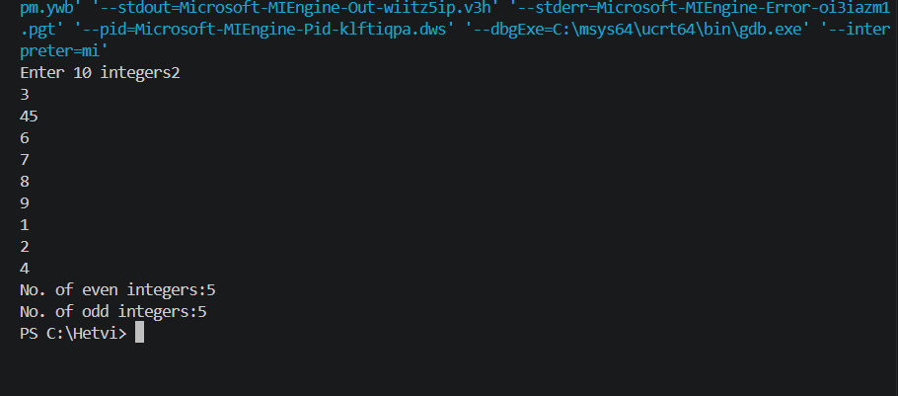
Question 45
//PROGRAM TO READ AN ARRAY OF 10 INTEGER AND COUNT TOTAL NO. OF POSITIVE, NEGATIVE, AND ZERO ELEMENTS.
#include<stdio.h>
int main()
{
int a[10],i,c=0,b=0,d=0;
printf("Enter 10 integers");
for(i=0;i<10;i++)
{
scanf("%d",&a[i]);

if(a[i]>0){
c++;
}
if(a[i]<0){
b++;
}
if(a[i]==0){
d++;
}
}

printf("No. of positive elements:%d\n",c);
printf("No. of negative elements:%d\n",b);
printf("No. of zero elements:%d",d);
}

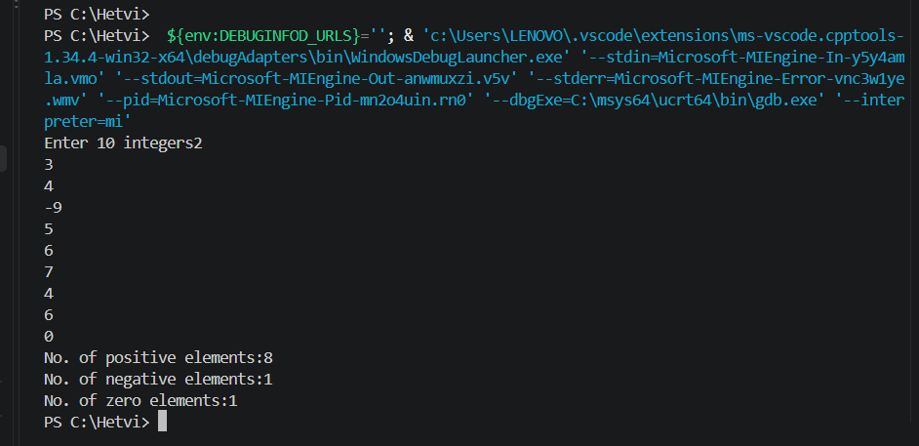
Question 46
//PROGRAM TO READ N NOS AND FINDOUT MAX AND SECOND MAX.
#include<stdio.h>
int main()
{
int i,n,a[n],max,smax;

printf("Enter size of array");
scanf("%d",&n);
printf("Enter no.");
for(i=0;i<n;i++)
{
scanf("%d",&a[i]);
}
max=a[0];
smax=a[0];
for(i=0;i<n;i++)
{
if(a[i]>max){
smax=max;
max=a[i];

}
else if(a[i]>smax&&a[i]!=max)
{
smax=a[i];
}
}
printf("Max. no. out of n:%d\n",max);
printf("Second Max. no. out of n:%d",smax);

}
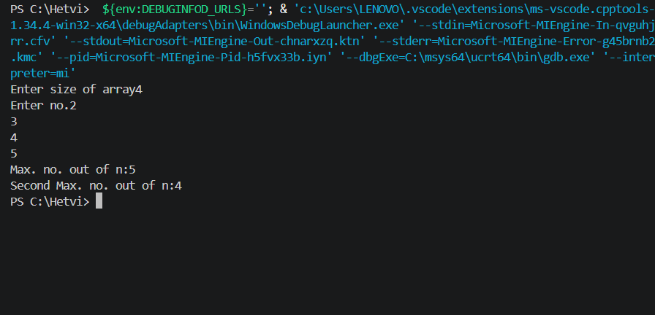

Question 47
//PROGRAM TO READ TWO ARRAYS OF 10 INTEGERS AND STORE ADDATION OF THOSE ARRAYS INTO THIRD.
#include<stdio.h>
int main()
{ int a[10],b[10],c[10],n,i;

printf("Enter size of array");
scanf("%d",&n);
printf("Elements of A array\n");
for(i=0;i<n;i++)
{
scanf("%d",&a[i]);
}
printf("Elements of B array\n");
for(i=0;i<n;i++)
{
scanf("%d",&b[i]);
}
printf("A\tB\n");
for(i=0;i<n;i++){
printf("%d\t",a[i]);
printf("%d\n",b[i]);
}
int sum=0;

for(i=0;i<n;i++){
c[i]=0;
c[i]=c[i]+a[i]+b[i];

}
printf("Sum:\n");
for(i=0;i<n;i++){
printf("c[%d]=%d\t",i,c[i]);
}
}
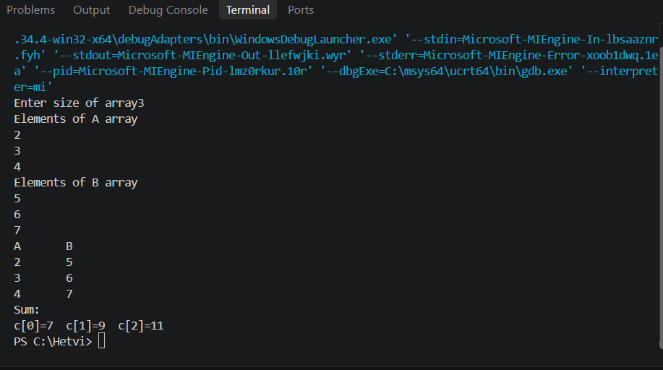
Question 48
//PROGRAM TO READ TWO ARRAYS OF 10 INTEGERS AND SWAP VALUES THESE ARRAYS.
#include<stdio.h>
int main()
{
int a[10],b[10],i,n,tamp[10];
printf("Enter size of arrays");
scanf("%d",&n);
printf("Enter elements of Array 1\n");
for(i=0;i<n;i++){
scanf("%d",&a[i]);
}
printf("Enter elements of Array 2\n");
for(i=0;i<n;i++){
scanf("%d",&b[i]);
}
for(i=0;i<n;i++){
tamp[i]=0;
tamp[i]=a[i];
a[i]=b[i];
b[i]=tamp[i];
}
printf("After swapping array elements\n");

printf("Array 1\t");
for(i=0;i<n;i++){
printf("%d\t",a[i]);
}
printf("\n");
printf("Array 2\t");
for(i=0;i<n;i++){
printf("%d\t",b[i]);
}
}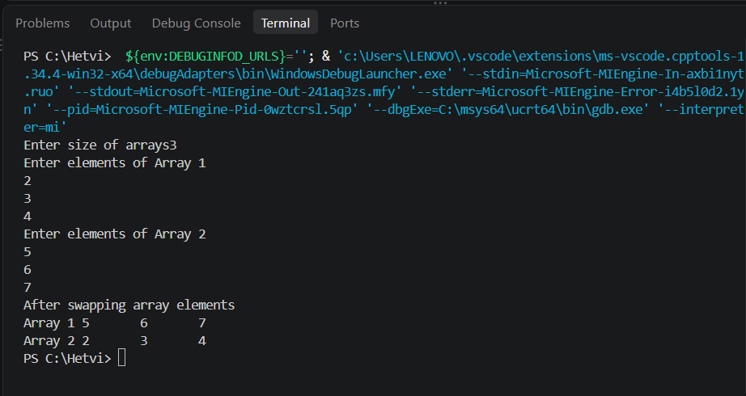

Question 49
// PROGRAM TO SORT (SELECTION SORT) AN ARRAY.
#include<stdio.h>
int main()
{
int a[5],i,j;
printf("Enter array elements:");
for(i=0;i<5;i++){
scanf("%d",&a[i]);
}
for(i=0;i<4;i++){
for(j=4;j>=i;j--){
int min=a[i];
if(a[j]<min){
int tamp=a[j];
a[j]=min;
a[i]=tamp;
}

}
}
printf("After selection sort:");
for(i=0;i<5;i++){
printf("%d\t",a[i]);
}
}
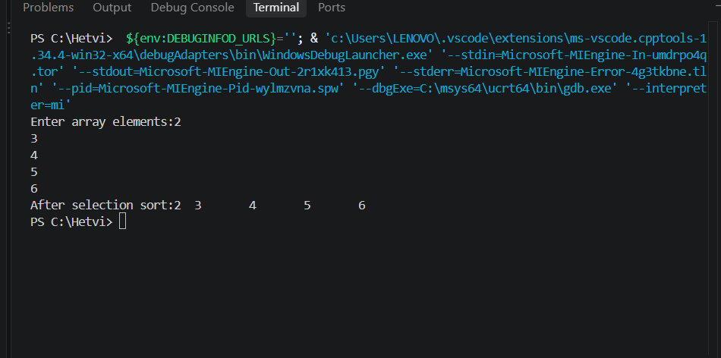
Question 50
//PROGRAM TO SORT (BUBBLE SORT) AN ARRAY.
#include<stdio.h>
int main()
{
int a[5],i,j;
printf("Enter array elements:");
for(i=0;i<5;i++){
scanf("%d",&a[i]);
}
for(i=0;i<4;i++){
for(j=0;j<5-i-1;j++){
if(a[j]>a[j+1]){
int tamp=a[j+1];
a[j+1]=a[j];
a[j]=tamp;
}
}
}
printf("After bubble sort\n");
for(i=0;i<5;i++){
printf("%d\t",a[i]);
}
}
